**The Financial Turmoil of August 2024**

**Frank Oz 8/17/2024**

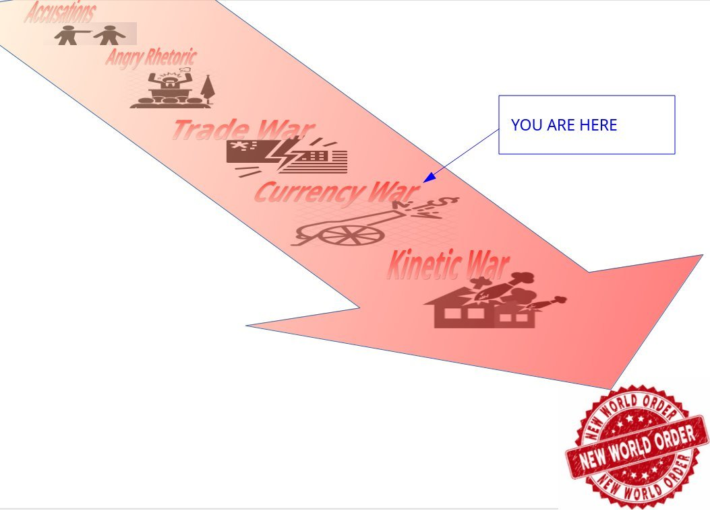

Last week was a hyper movement of currencies. It was by far nearly one of the fastest weakening of the USD in history. There is more going on than meets the eye – namely, the russian ruble. It was on a solid trajectory to breach 80 rubles to 1 dollar.

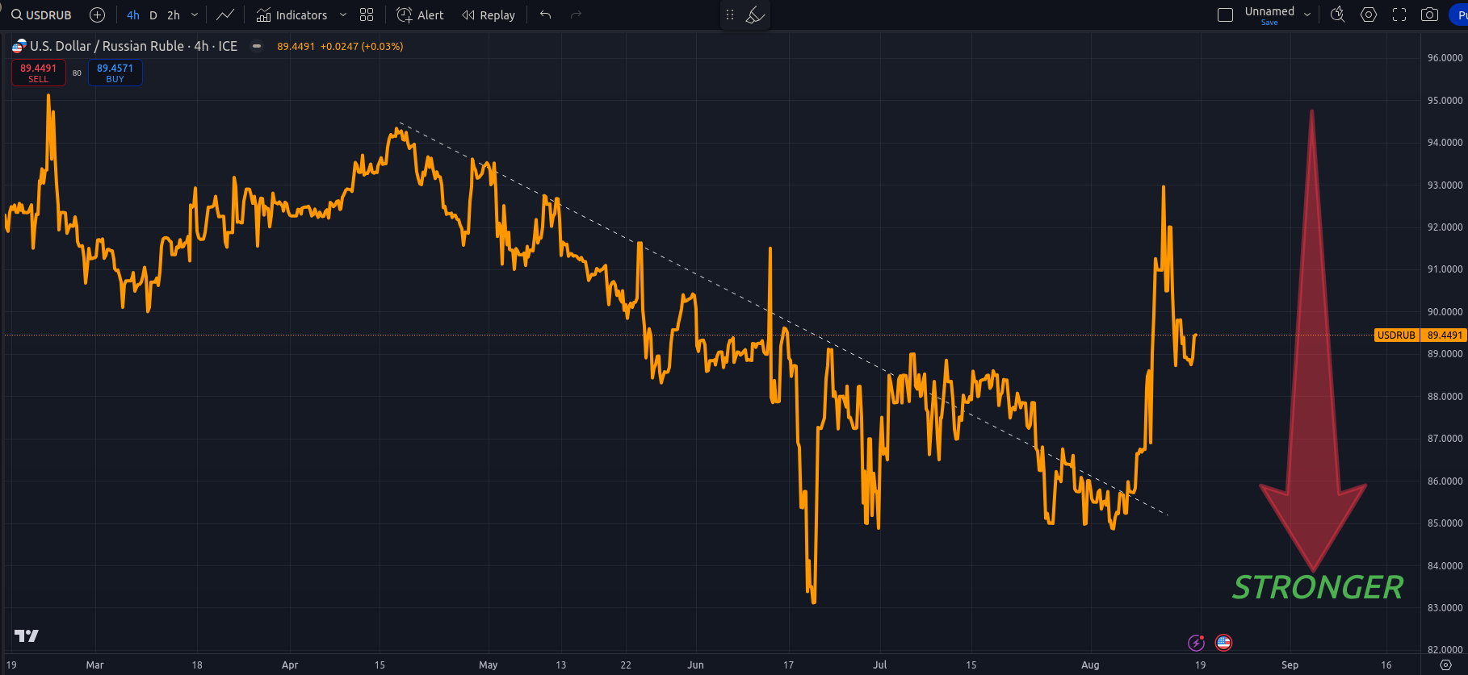

Notice that spike on the right – we will come back to that.

You first need some background information on how bonds and currency strength works. Some of you who read my 301 thread on cross border currency flows already know all this

<https://x.com/frankoz95967943/status/1761368953103003963>

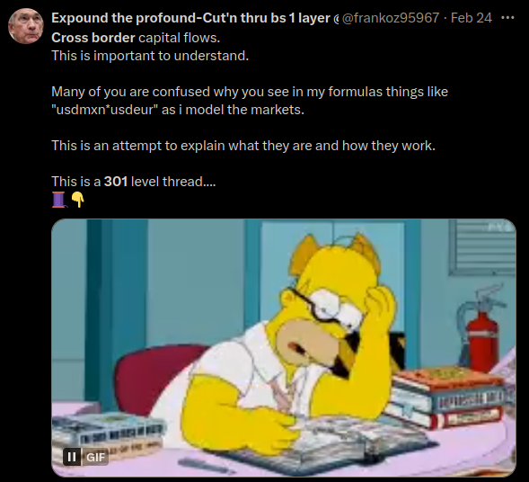

When Country A buys Country B’s debt, Country A’s currency gets stronger.

You can move currency strength around in a system thru the bond market (debt = bonds).

Canada produces a lotta oil. They also produce maple syrup, mooses, Tim Horton's and igloos. <https://x.com/frankoz95967943/status/1820343540502941821>

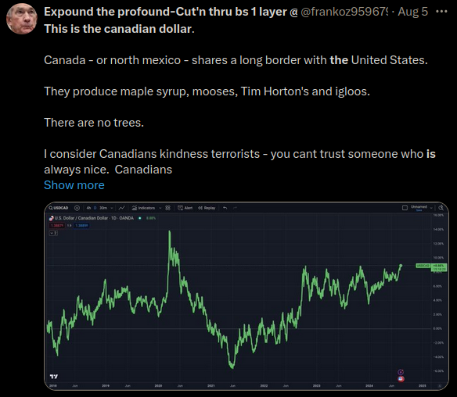

When canada exports that oil, their currency gets stronger. And the price of oil would naturally rise if the demand for that oil rises.

But that didnt happen.

Canadian dollar got WEAKER.

How did this happen?

The central planners decided to move the currency strength from canada to mexico.

Mexico produces fentanyl, avocado’s, and criminal gangs.

By moving currency strength from canada to mexico, your fentanyl and avocado’s got more expensive, but the canadian oil got cheaper.

Because oil is in everything, oil is inflation. Which is why the planners did this.

But notice (3)....just like in the chart above something happened here....

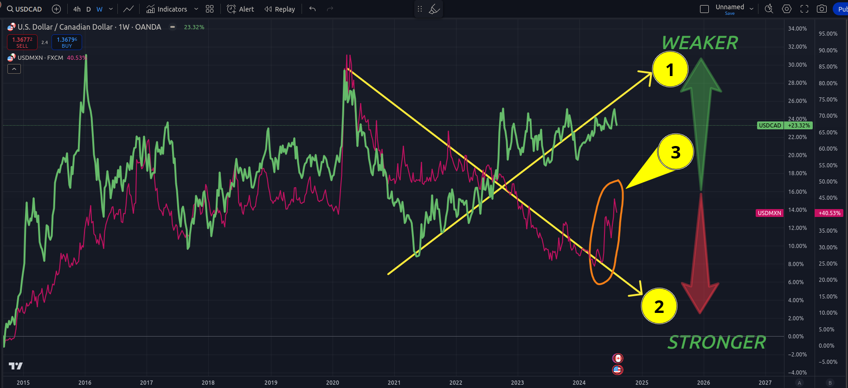

Same chart – ive added the CNYMXN currency pair.

By moving the carry – and canadian currency strength – to mexico, the carry has quieted the vix.

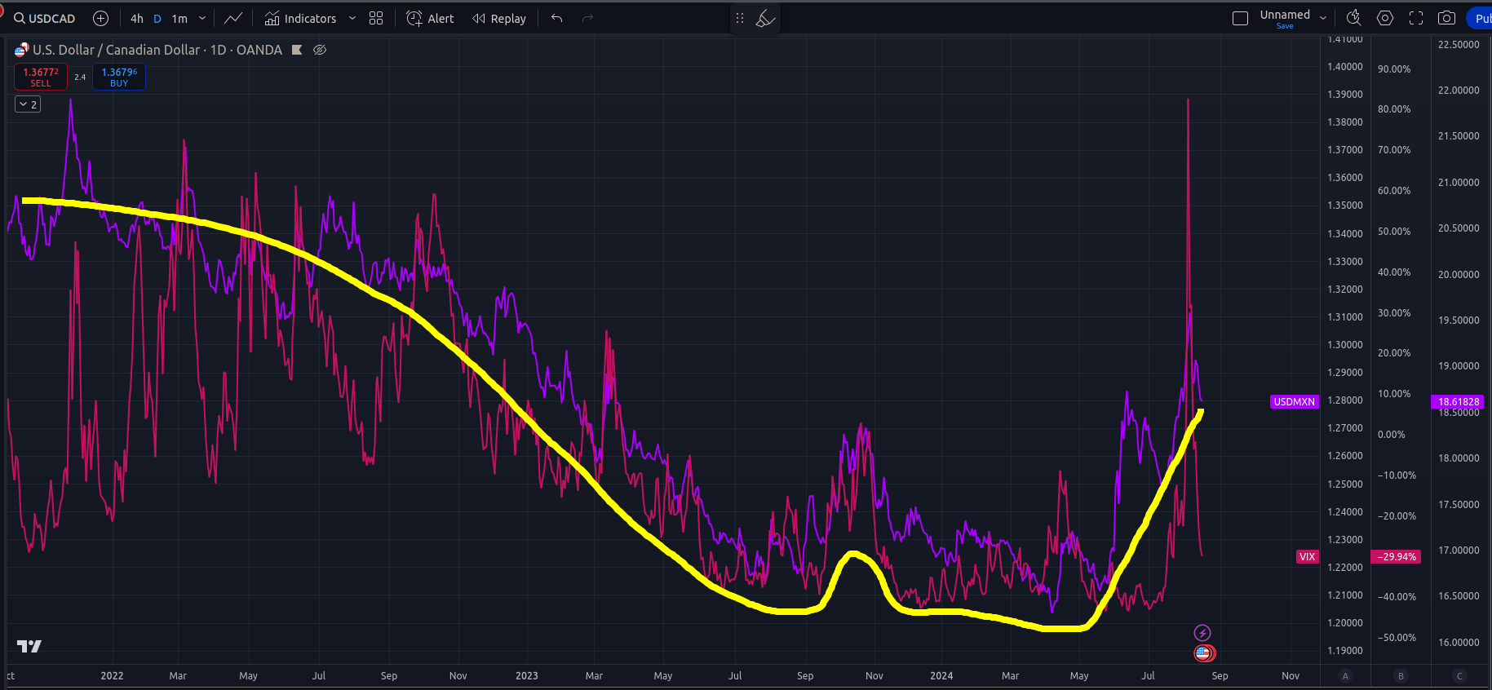

Except – see that spike on the right? Just like all the other spikes – this system is all interconnected....

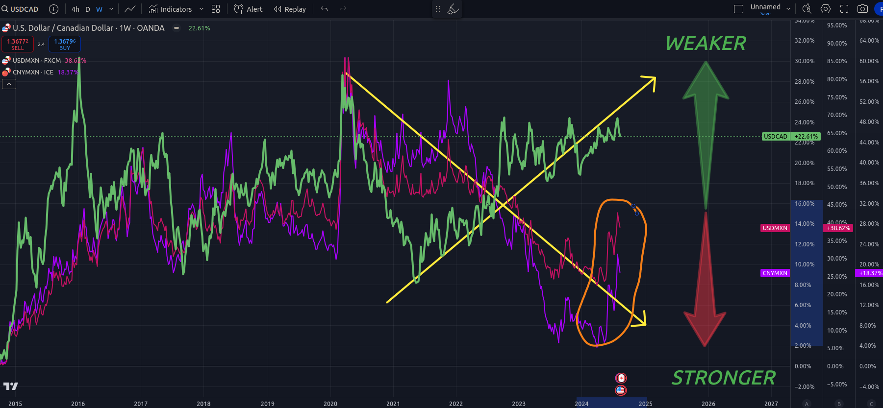

See the spike also in CNY?

So a couple things could have happened here.

1. Mexico could have devalued their currency
2. Mexico sold FX reserves
3. China (or someone in the east) bought a LOT of Mexican debt

And in doing this it caused the little cherade of hiding currency strength from canada into mexico to blow up....and then the vix spike.

Which was one of the biggest single day vix spikes since covid.

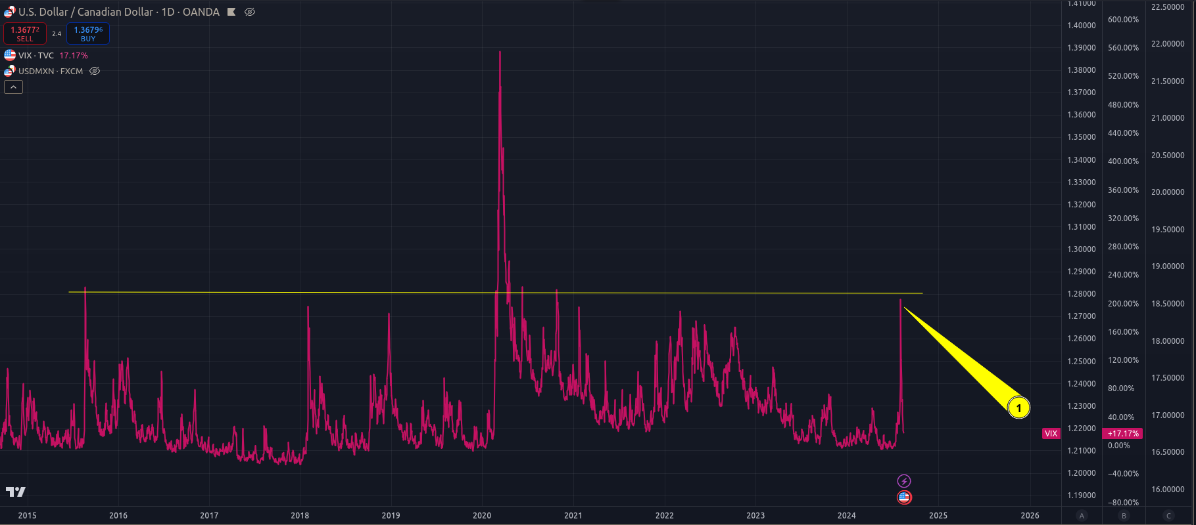

And it was one of the SHORTEST vix spikes on record too....usually it takes a few weeks for this to work itself out of the system. This one took DAYS.

Lets go back to that first chart – and add the vix... After the vix spike happened? The ruble got trashed.

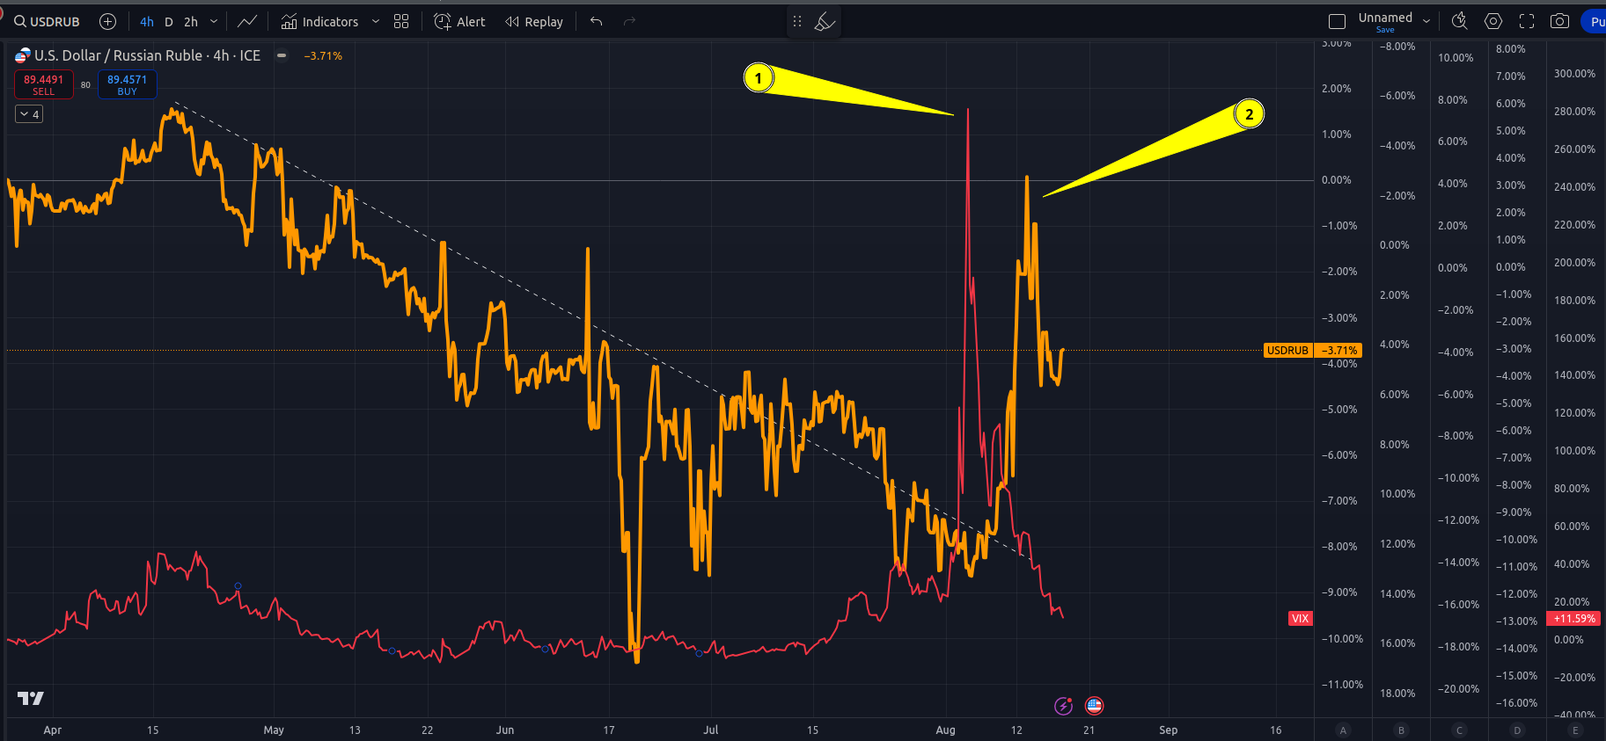

It appears to me china may have started buying mexican debt around the end of may....and this likely caused great disruption in the currency games the west has been playing on oil....

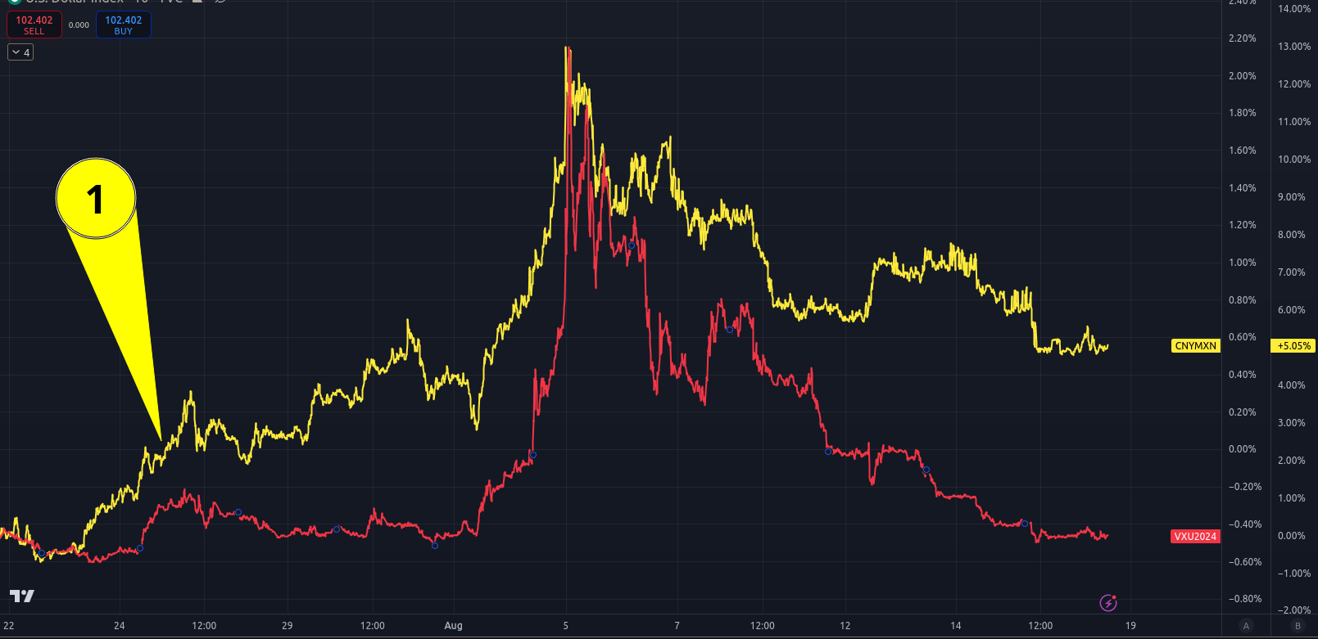

I think china has figured out how the jPan, jFed, and jAnet have been able to suppress oil for so long.

And once discovered, jPan, jFed, and jAnet went into panic and told G6 to buy US debt as fast as possible otherwise the entire western financial ponzi would blow up....

And they got the message loud and clear...that blue line on this chart? Up means their collective currencies got STRONGER

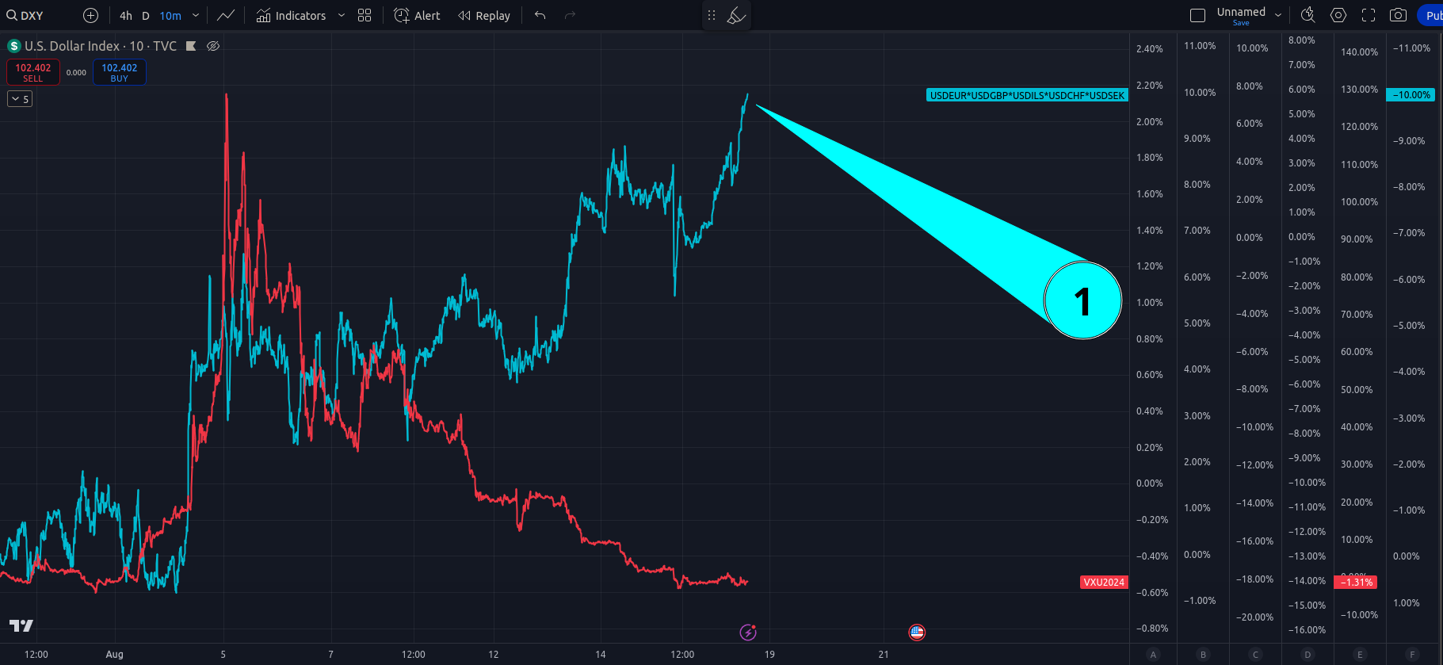

And if they get stronger? The dollar (1) and dxy (2) get WEAKER

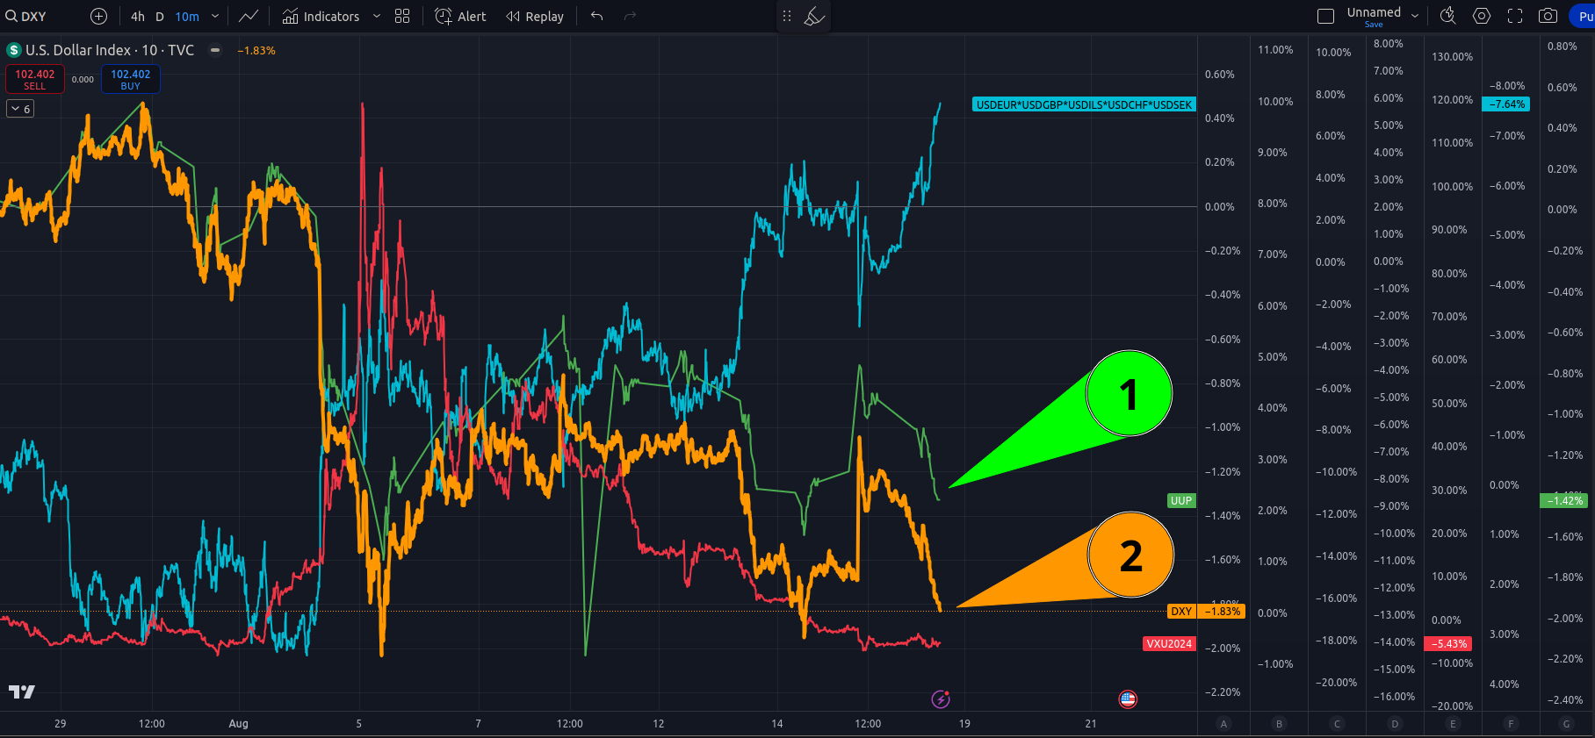

And this drove the vix right into the ground

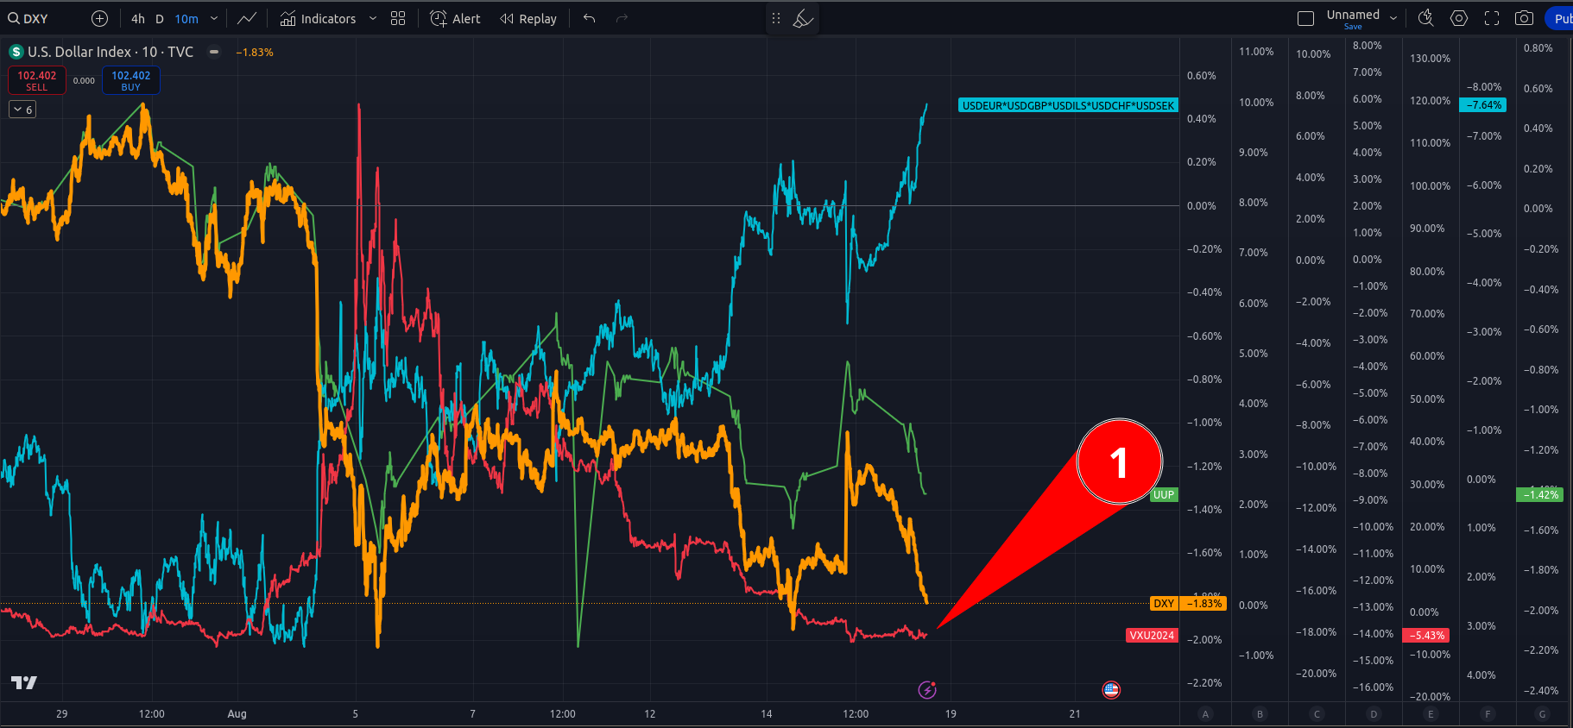

Saving the stonk...

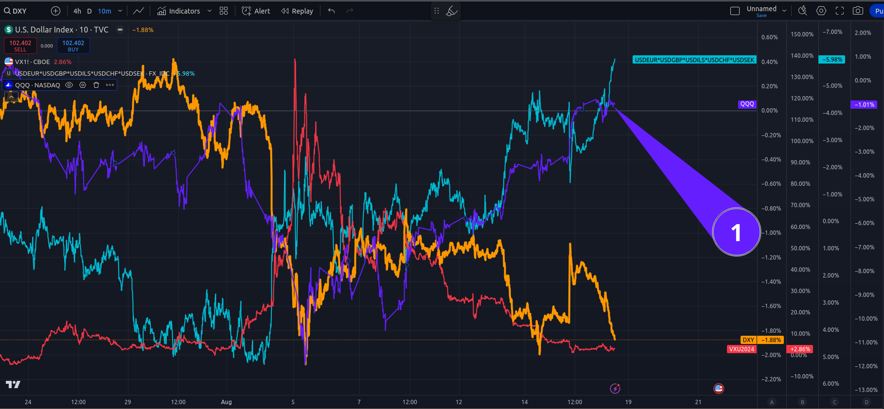

Here is the mexican bond yield – thats a significant drop and it coincides with Aug 5th....

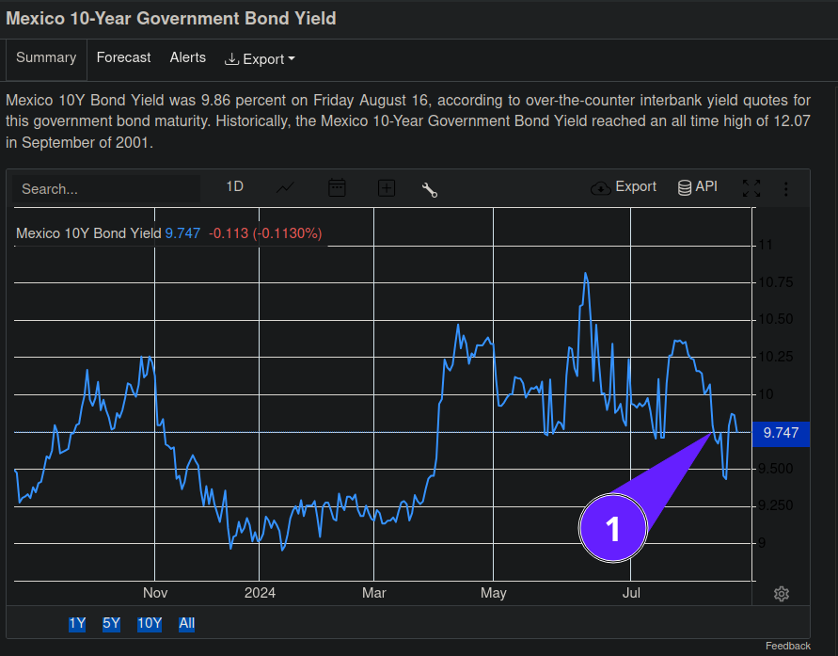

This is how its spun to you in the press...

https://economictimes.indiatimes.com/markets/forex/mexicos-peso-extends-losses-on-fears-of-us-recession/articleshow/112282471.cms?from=mdr

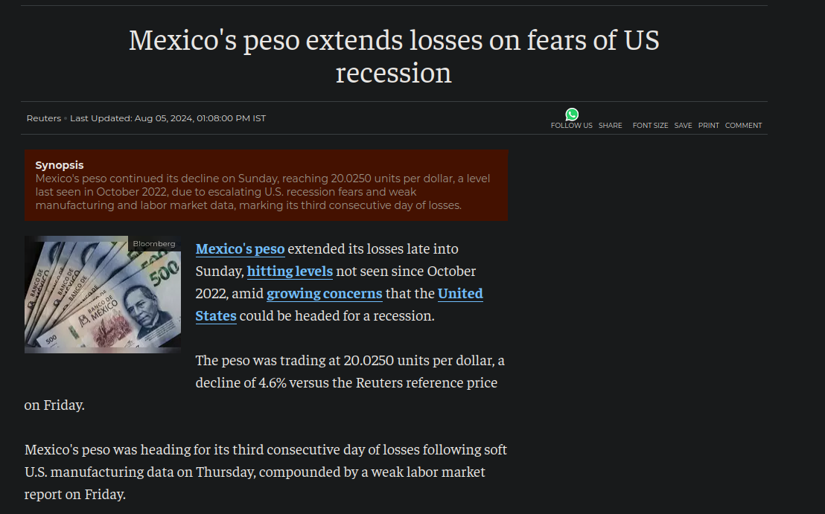

Here i’ve inverted the vix – notice how currencies and the vix correlate.

When the vix drops like this – premium on puts is absolutely destroyed – it forces people who hold bets against the market to either close the position or sell vol to cover the position.

This was a VERY violent move against puts – one of the most extreme in history.

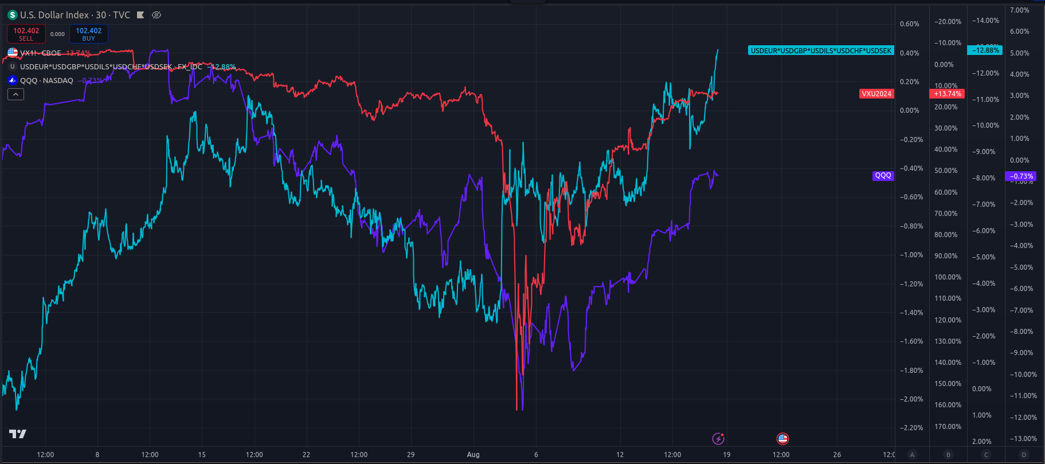

Here is foreign currencies as expressed thru mexican pairs – many of these countries peg to the USD so you cant see whats actually happening to their currency strength with the rest of the world – i just multiply them together for ease of looking at the data.

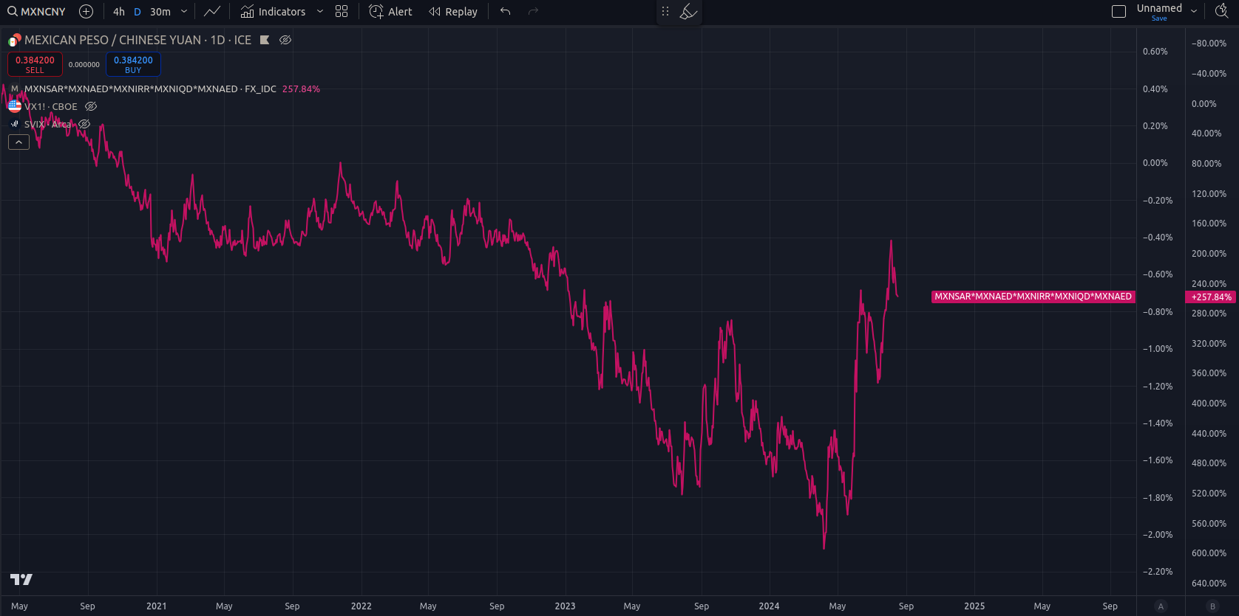

Notice that same spike on the right?

Here is the svix with oil producing nations currencies...

The svix and mexico have been used as a weapon to weaken their currency and lower the price of oil...

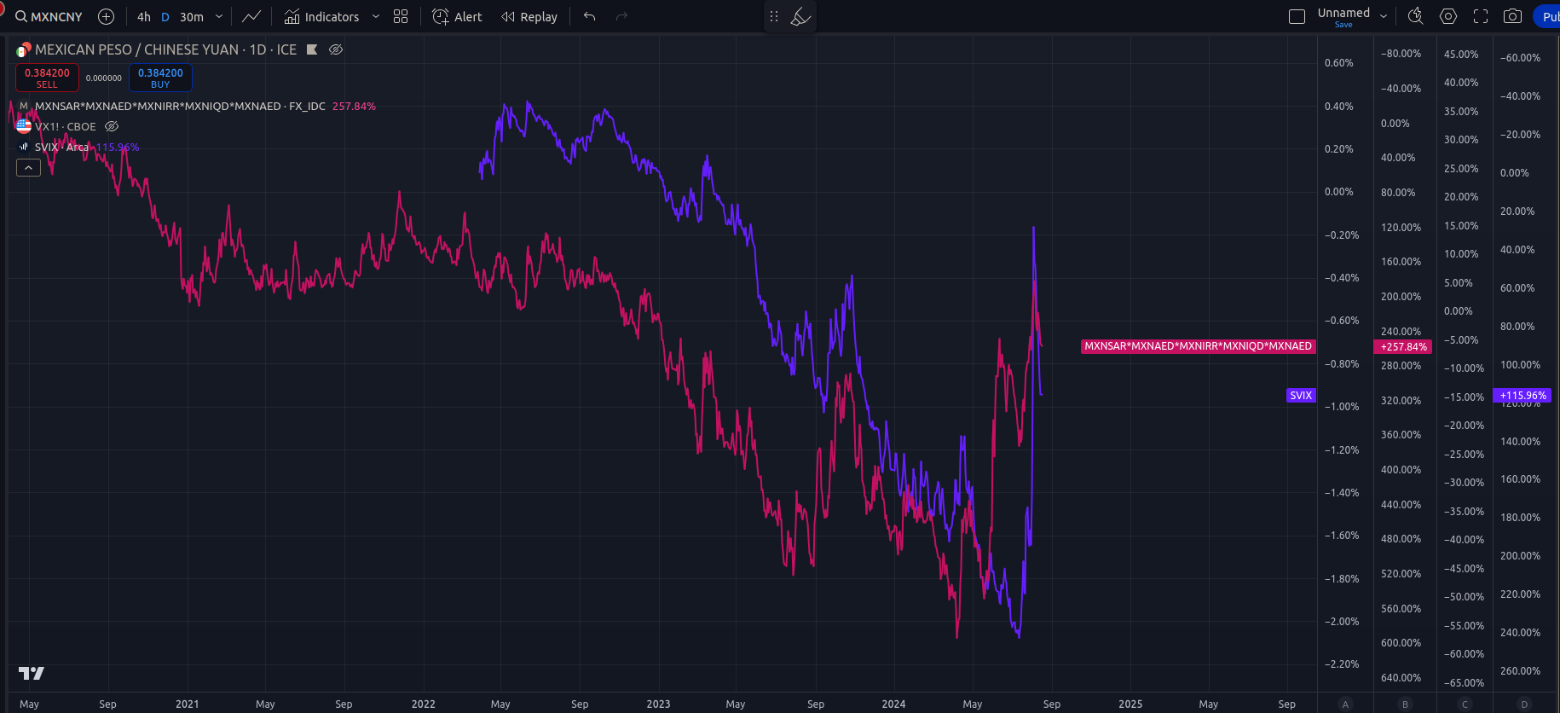

And here is the vix – yes, they are all correlated. There is an active war against oil producing nations – including russia – and the vix, likely BECAUSE of the vix.

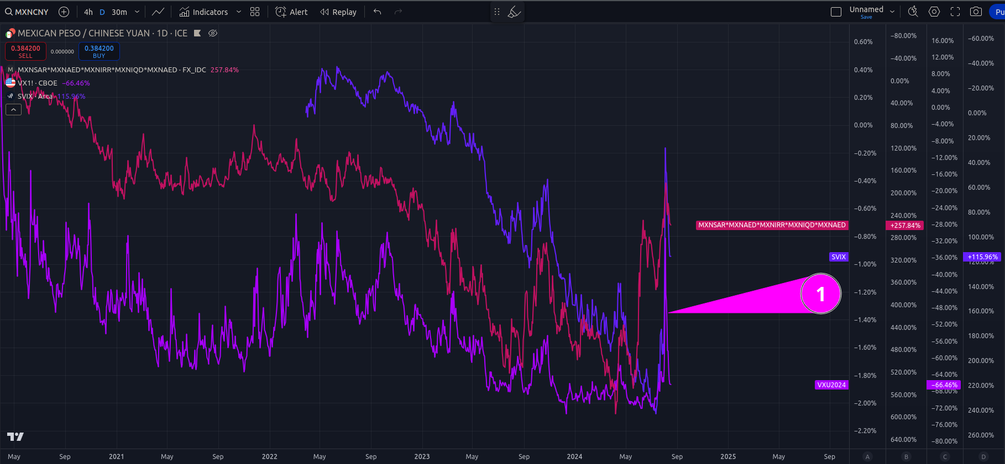

Same chart zoomed in

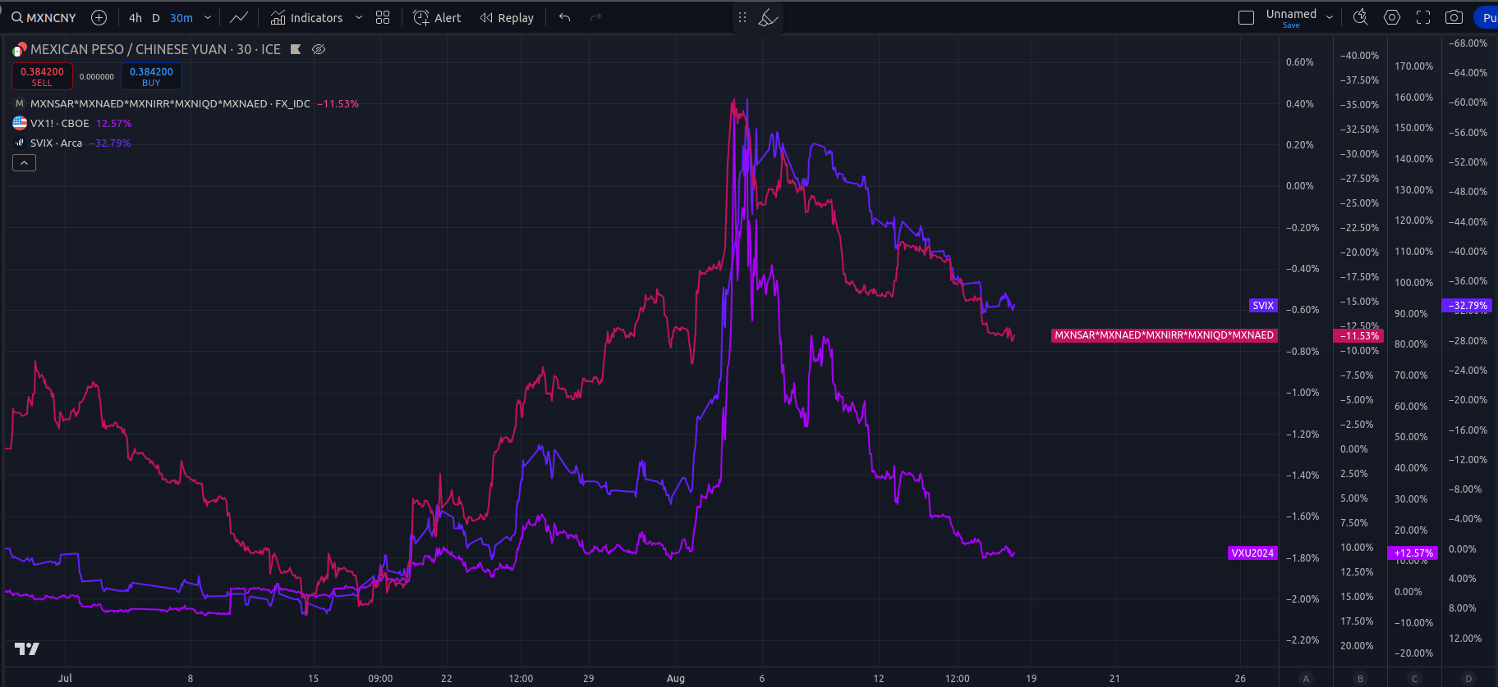

Same chart zoomed in with G6 currencies

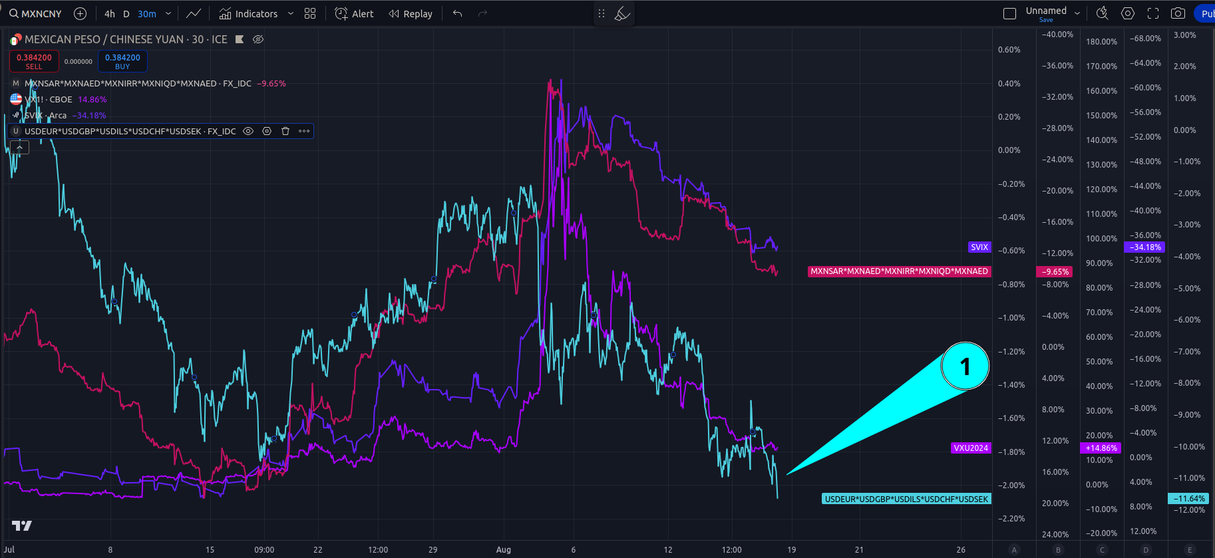

Same chart with oil

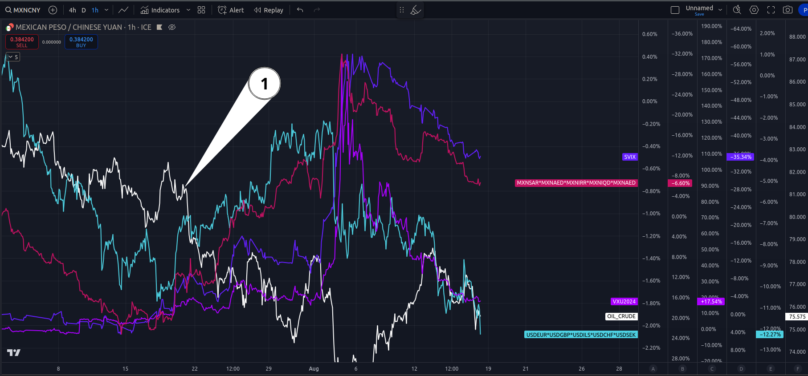

What you need to understand is a HIGH vix = deflation – stonk goes down, commodities go up. USA is in the (2) regime.

August 5th was (4) regime – someone fucked up.

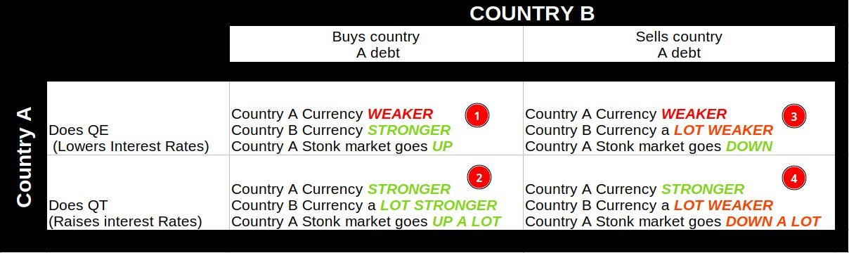

To fight a currency war you need your currency WEAKER.

This is why jAnet is doing YCC.

Its why we get a new volatility suppressive suppository every other week.

A strong USD = vix explosion.

jPan is the worlds #1 carry trade country – they arent the only one – more on that in a minute – here is the US30y long bond vs jPanesa. They regulate global currencies and bonds as saud regulates oil and beheadings. The US long bond moves right along with jPanesa currency – because they hold so much of it what they do matters a lot. As you can see, when the bond yield goes down, jPan currency also gets STRONGER – meaning – they bought US treasury bonds. When china bought mexican bonds – jPan had to react fast else their short on the vix might blow up. They real quick tried to weaken the dollar, and in doing so, likely caused that vix spike.

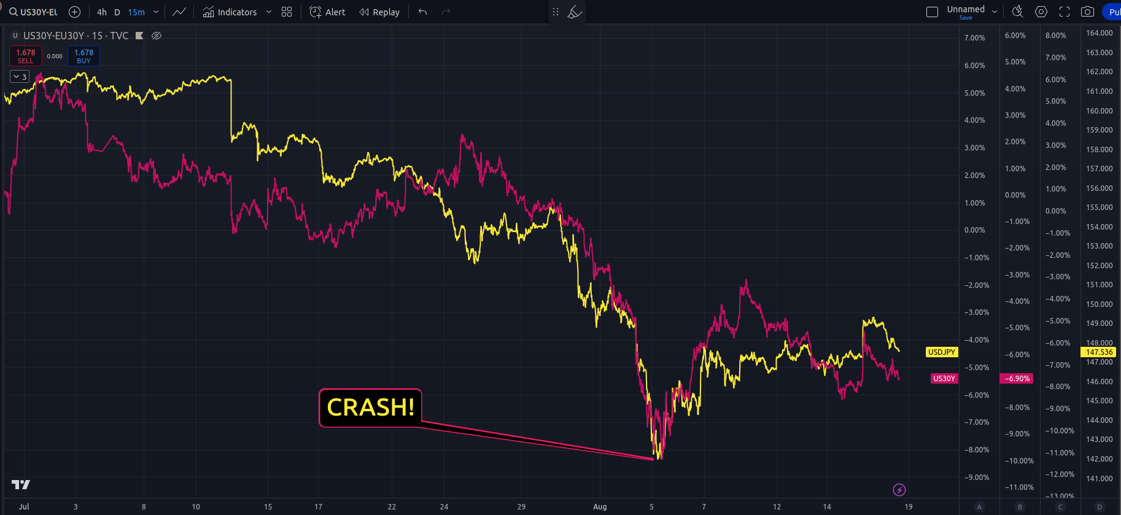

Here is the euro-p bond. Euro-P needs to keep a ratio of its bond to US bond in order to get anyone to buy their debt. But they too are carry traders.

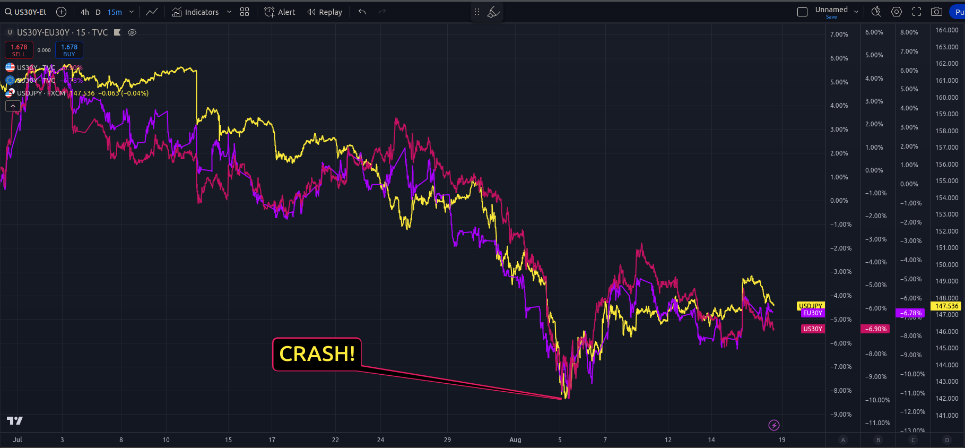

The green line is the Euro-P carry trade. They need a spread between US and EU bonds – if you remember back, EU cut interest rates – so rn – its very lucritive to borrow in EU$ and buy US treasuries – if that spread tightens the carry collapses and they have to close the trade otherwise they take losses. That crash was that event i think – the central bank couldnt react fast enuf to the change in spread jPan induced dealing with china’s purchase of Mexican long bonds.

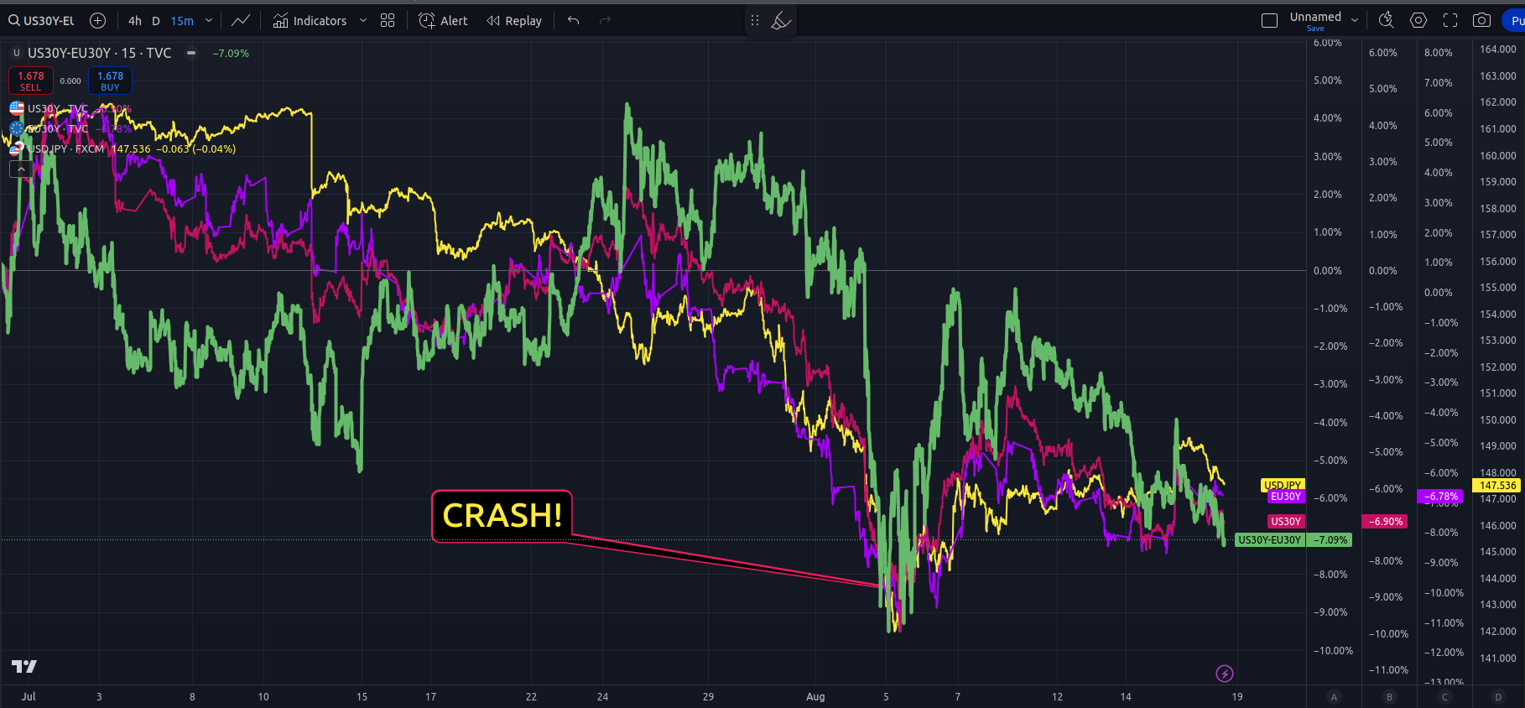

And ya, if you are wondering how the financial system works – it looks something like this:



“One mans debt is another mans asset” — r. dalio

And this is exponentially, rehypotheticated and levered 1000:1 true today....

<https://www.investopedia.com/terms/r/rehypothecation.asp>

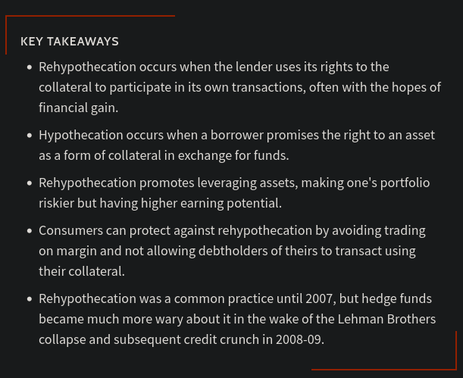

What he said...

<https://www.youtube.com/watch?v=ANC2ZFg_oQA>

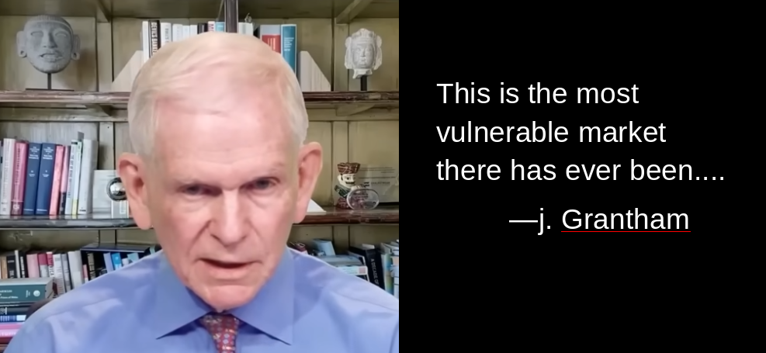

What all this carry trade does is suppress volatility – and that should now be obvious from the pages above. Risk isnt gone – its just suppressed.

<https://www.youtube.com/watch?v=mDcUF5ibHt4&t=2s>

And this is why we are seeing daily 10-15 point moves in indexes; these swings are getting bigger every single day – and this is VERY not normal....These gaps are from currency imbalances in the overnight market.

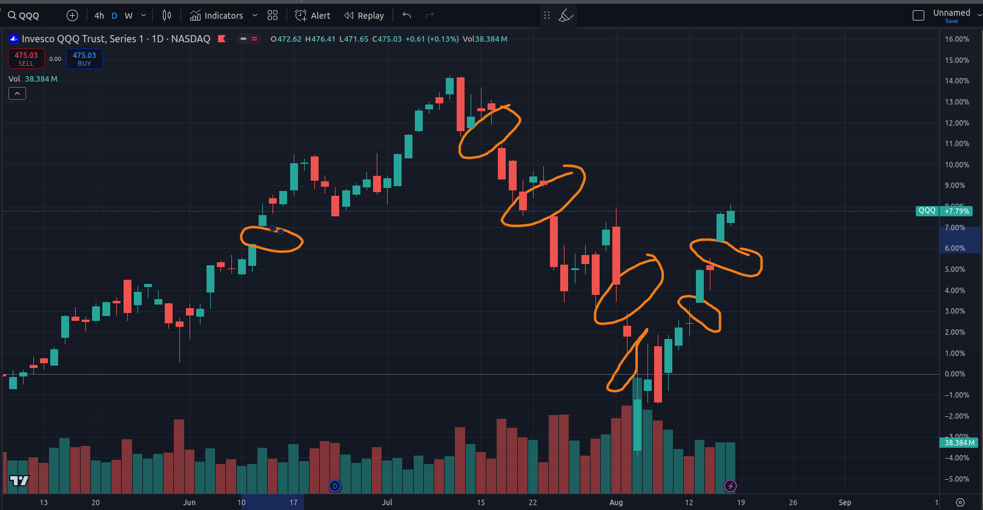

If you’ve followed me for any length of time you know my feelings towards the boing. Its just a terrible company. Leaving astraunots stranded on space station, burning $1,000,000,000 per month, having planes pile up in yard because your supply chain is completely disrupted, or having regulators breathing down your neck because you used defective parts on planes and you cant provide sufficient evidence of a stable compliant parts list..... None of that matters if the dollar is weakened thru carry trade and likewise the vix is crushed to dust.

In the past week boing has rallied over 1000bp. Boing is being rewarded for fucking up. Only in america.....

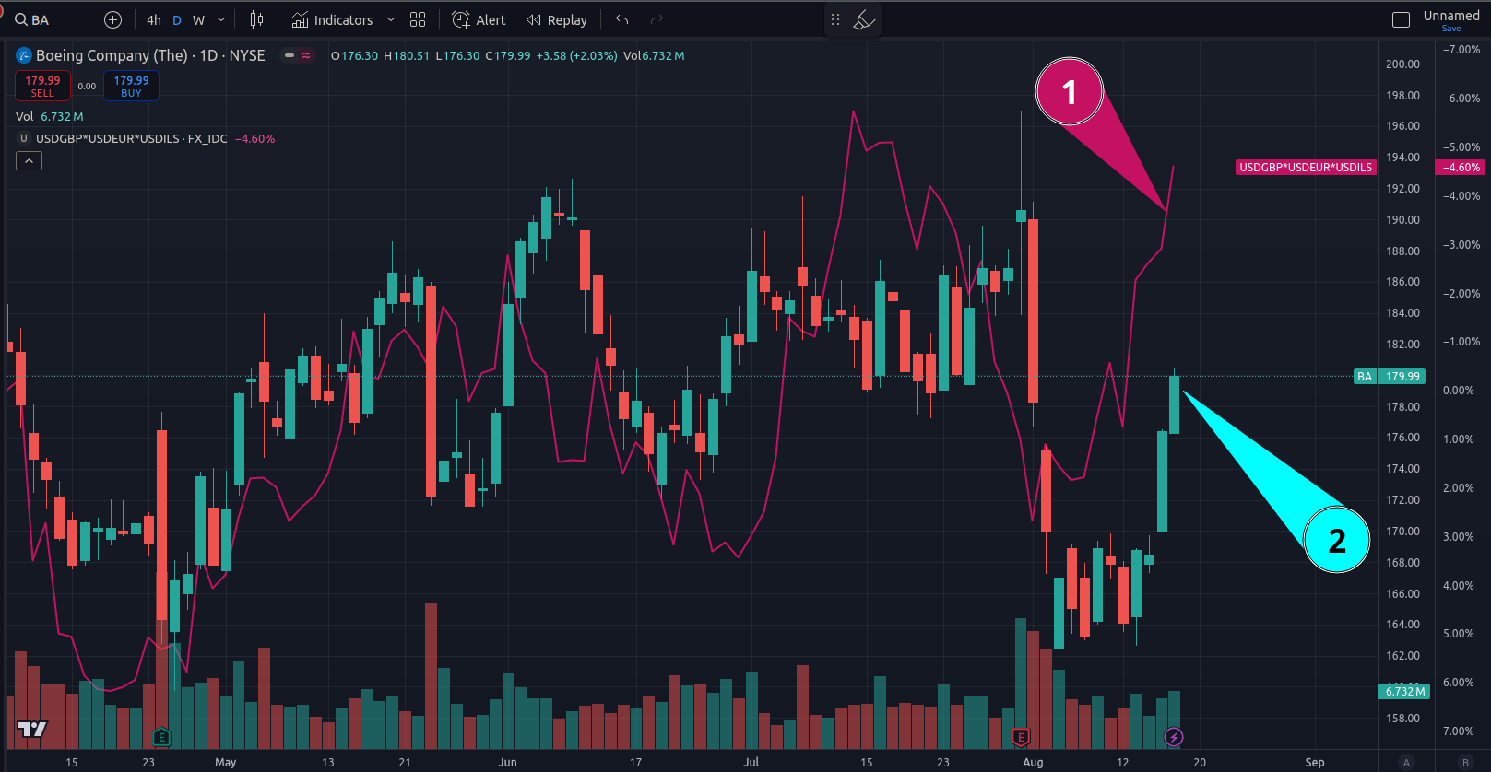

When these foreign governments – Euro-P, Germany, Brits – buy US bonds – ya, they lock in a lower oil price – but they also KILL their export market. Their currency strengthens. This makes their exports MORE expensive. Any company in EU that exports now is less competitive based on currency exhcange rates alone.

Meanwhile, US companies now have an advantage to export to Europe.

